Game Design Document For

**Medellín CITY**

**"CREATE YOUR OWN CITY, AND BE THE BEST MAYOR**."

Version 1.0

2018

**GAME DESIGN DOCUMENT**

**Medellín CITY**

**Juan David Barrera Urrego**

**Ficha: 1319447**

**Víctor Hugo Cardona**

**Alejandro**

**(Instructores)**

**SERVICIO NACIONAL DE APRENDIZAJE**

**Centro de servicio y gestión empresarial**

**Industrias Creativas**

**Medellín**

**2018**

Contenido

**GAME OVERVIEW** 5

HIGH CONCEPT: 5

PHILOSOPHY 5

HOW CAN I DO IT? 5

FEEL THE POWER 5

FEEL THE RESPONSIBILITY 5

**COMMON QUESTIONS** 6

WHAT IS THE GAME? 6

WHAT DO I CONTROL/ WHO AM I? 6

WHERE DOES THE GAME TAKE PLACE? 6

WHAT ARE THE GOALS/OBJECTIVES OF THE GAME? 6

Long Term 6

Mid Term 6

Short Term 7

WHAT IS THE MAIN FOCUS? 7

WHAT’S DIFFERENT? 7

**FEATURE HIGHLIGHTS** 7

BUILD BUILDINGS AND STREETS. 7

MANUFACTURE PRIMARY MATERIALS FOR CONSTRUCTION. 7

AVOID POLLUTION. 8

MAP VIEW 8

CONTROL OVERVIEW 8

PC CONTROL SCHEME 8

**FEATURE DETAILS** 8

BUILD HOUSES. 8

BUILD DIFFERENT TYPES OF BUILDINGS. 9

THE COLTEJER: 9

THE WAREHOUSE: 9

THE BANK: 10

THE FACTORY: 10

BUILD STREETS 10

CONTROL OF RESOURCES. 11

LEVEL UP 12

INCREASE THE NUMBER OF INHABITANTS. 12

PROSPERITY 12

GAME CHARACTERS 13

Main Character: 13

NPC CHARACTERS: 13

**MUSICAL SCORES AND SOUND EFFECTS** 13

MUSIC 13

MENU MUSIC: 13

GAME MUSIC: 13

**GAME INTERFACE** 13

# **GAME OVERVIEW**

## HIGH CONCEPT:

**"Create your own city and become mayor"**

Medellín CITY is a construction game of cities in 3D, where the player takes the role of mayor and is responsible for building his city from scratch.

The player controls his city and is in charge of creating the different constructions so that he can prosper.

The player can build houses, buildings and other constructions that will help his city grow. The player must take the pollution meter into account and ensure that it does not get full and that he has to start the game again.

## PHILOSOPHY

### HOW CAN I DO IT?

The player starts the game with a tutorial stating that he is the mayor of a new city, which is where the player asks "How can I do it?", And your question will be resolved as soon as the tutorial ends and start creating your city.

### FEEL THE POWER

I want the player to feel the power to manage a city at will and decide where, when, and what he wants to build.

### FEEL THE RESPONSIBILITY

I want the player to feel the responsibility that a mayor has in front of a city and its inhabitants.

The player must maintain a balance between the size of his city and the amount of pollution it produces.

# **COMMON QUESTIONS**

WHAT IS THE GAME?

Medellín CITY is a construction game of cities with elements of construction that allow the growth of the city that is being built.

The player takes on the role of mayor and is responsible for controlling the progress of his city.

The player uses houses, buildings and streets to make his city prosper and his experience as mayor increases.

## WHAT DO I CONTROL/ WHO AM I?

The player is the mayor and controls the city.

To build the city the player must possess the necessary resources for each construction.

At the time of construction, each construction gives the player experience, prosperity, increases the number of inhabitants and the amount of pollution.

## WHERE DOES THE GAME TAKE PLACE?

The game takes place in a place similar to the place where the city of Medellin-Colombia is located. Which is divided in two by a river.

WHAT ARE THE GOALS/OBJECTIVES OF THE GAME?

### Long Term

-Construct a town and you have to prosper so that it can become a beautiful city. -complete the objective of each level.

Mid Term

-Make your population grow until it becomes a small city.

-Complete the objective of each level.

- maintain a balance in the amount of contamination.

### Short Term

-Convert your small city into a big city.

-Construct all the possible construction elements for your city.

-Occupy all available space to build, maintaining a balance in pollution.

-Avoid that the pollution indicator be 100% filled.

WHAT IS THE MAIN FOCUS?

The main focus is to build and prevent the pollution indicator from filling up.

## WHAT’S DIFFERENT?

The main difference of Medellin CITY with other games of construction of cities, is that in Medellin CITY you can find representative buildings of the city of Medellin-Colombia, besides the land available to build is similar to the valley where the city of Medellin is located.

All items can be purchased within the game.

# **FEATURE HIGHLIGHTS**

The following is a list of the game's features listed in order of priority. The section below gives more

details for each feature.

## BUILD BUILDINGS AND STREETS.

The player will build houses, buildings and streets to make his city grow, but for this, he must know how to do it.

## MANUFACTURE PRIMARY MATERIALS FOR CONSTRUCTION.

The player must make the necessary elements for the construction of streets and buildings, but for this he must pay with gold or gems.

## AVOID POLLUTION.

Prevent the contamination indicator from filling up completely or you will have to start over.

For this you must build the different available elements that help to lower the pollution level of your city.

## MAP VIEW

The player can zoom in or out to better see his city or what he wants to build at the moment.

CONTROL OVERVIEW

PC CONTROL SCHEME

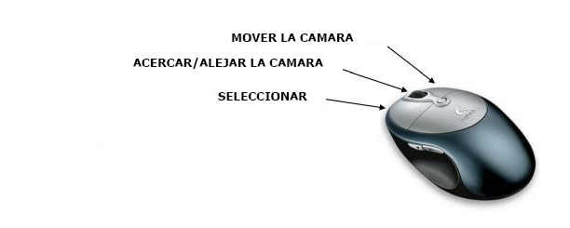

# **FEATURE DETAILS**

The following are the fine details of all the features in the game, listed in order of priority.

BUILD HOUSES.

The player can create 2 different types of houses of level 1, one of them with gold and another with gems.

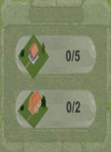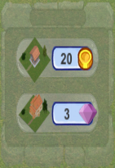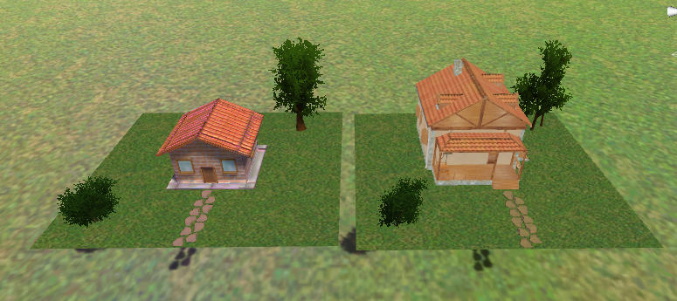

## BUILD DIFFERENT TYPES OF BUILDINGS.

The player can create 4 different types of buildings which are El Coltejer, the warehouse, the bank and the factory.

## THE COLTEJER:

The Coltejer Building (or Coltejer Center) is a building in Medellín (Colombia). It was built on the old Junín theater and the Europa hotel, starting in 1968 and ending four years later, in 1972, becoming until 1977 the tallest building in the country, when the International Trade Center, surpassed it in height. This was also the tallest building in Latin America until the World Trade Center Mexico exceeded the same year

THE WAREHOUSE:

The warehouse is responsible for storing the materials used for construction.

## THE BANK:

The bank is responsible for collecting the money generated by the inhabitants of the city.

## THE FACTORY:

The factory is responsible for producing the necessary materials to build.

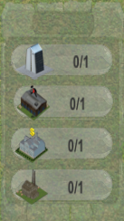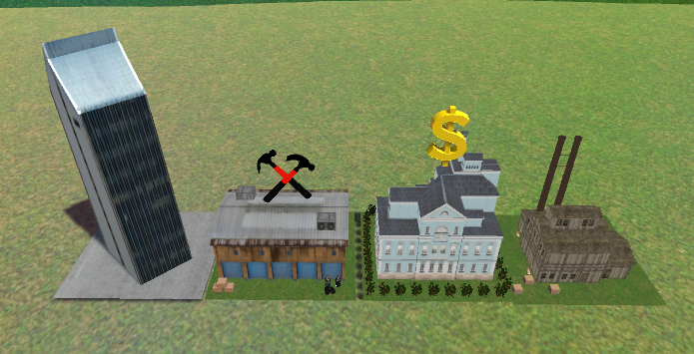

## BUILD STREETS

The player can build different streets, among which are, straights, curves, and intersections.

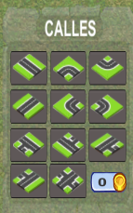

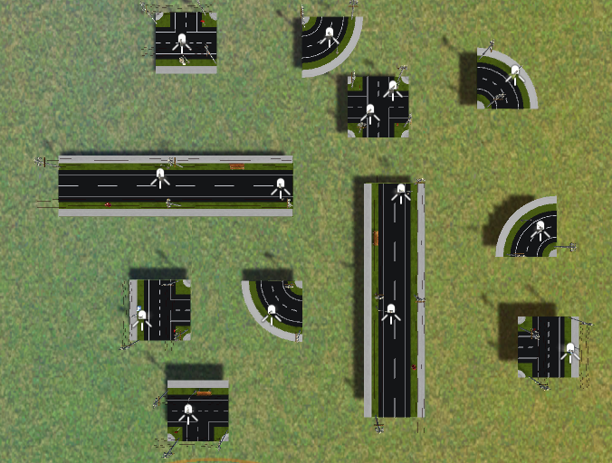

CONTROL OF RESOURCES.

The player can see how many materials he has stored and how many more he can have, besides being able to see the amount of gems and gold he has.



## LEVEL UP

The player increases in level as his city prospers and his population increases.

In addition, the player can see what level he is and how much he needs to reach the next level.

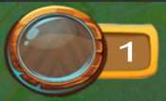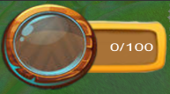

## INCREASE THE NUMBER OF INHABITANTS.

Each time the player builds, the number of inhabitants increases.

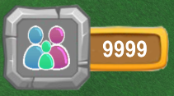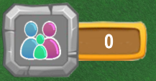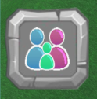

PROSPERITY

Every time the player builds, pollution increases and the prosperity of the city decreases.

The player must maintain a balance between the two.

If the pollution indicator goes up to 100% and the prosperity drops to 0%, the player loses his title of mayor and must start the game again.

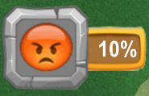



# GAME CHARACTERS

## Main Character:

The Mayor is the main character of the game, and this role is developed by the player.

## NPC CHARACTERS:

The character of NPC is Bob the builder who helps the Mayor in the process of building the city.

# **MUSICAL SCORES AND SOUND EFFECTS**

The overall sound of the game should complement the abstract visual style.

## MUSIC

MENU MUSIC: https://freesound.org/people/PatrickLieberkind/sounds/396024/

GAME MUSIC: <https://freesound.org/people/Freed/sounds/93287/>

# **GAME INTERFACE**

GAME VOLUME

CREDITS

OPTIONS

START GAME

TUTORIAL